**San Francisco Bay University**

**MATH201 - Calculus-I**

**Homework Assignment #3**

**Due day: 6/23/2023**

**Instruction:**

1. **Push the answer sheet to Github in word file**
2. **Overdue homework submission could not be accepted.**
3. **Takes academic honesty and integrity seriously (Zero Tolerance of Cheating & Plagiarism)**
4. If a rock is thrown upward on the planet Mars with a velocity of 10 m/s, its height in meters *t* seconds later is given by

(a) Find the average velocity over the given time intervals:

(i) [1, 2]

[1, 2]: (10(2) - 1.86(2)^2 - (10(1) - 1.86(1)^2)) / (2-1) = 6.28 m/s

(ii) [1, 1.5]

[1, 1.5]: (10(1.5) - 1.86(1.5)^2 - (10(1) - 1.86(1)^2)) / (1.5-1) = 7.135 m/s

(iii) [1, 1.1]

[1, 1.1]: (10(1.1) - 1.86(1.1)^2 - (10(1) - 1.86(1)^2)) / (1.1-1) = 7.698 m/s

(iv) [1, 1.01]

[1, 1.01]: (10(1.01) - 1.86(1.01)^2 - (10(1) - 1.86(1)^2)) / (1.01-1) = 7.83398 m/s

(v) [1, 1.001]

[1, 1.001]: (10(1.001) - 1.86(1.001)^2 - (10(1) - 1.86(1)^2)) / (1.001-1) = 7.85167 m/s

(b) Estimate the instantaneous velocity in Excel when

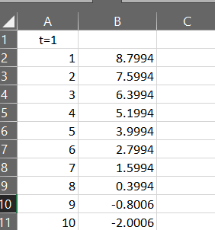

1. The displacement (in centimeters) of a particle moving back and forth along a straight line is given by the equation of motion , where *t* is measured in seconds.
2. Find the average velocity during each time period:
3. [1, 2]

[1, 2]: ((2sin(π2) + 3cos(π2)) - (2sin(π1) + 3cos(π1))) / (2-1) = -3 cm/s

1. [1, 1.1]

[1, 1.1]: ((2sin(π1.1) + 3cos(π1.1)) - (2sin(π1) + 3cos(π1))) / (1.1-1) = -2.996 cm/s

1. [1, 1.01]

[1, 1.01]: ((2sin(π1.01) + 3cos(π1.01)) - (2sin(π1) + 3cos(π1))) / (1.01-1) = -2.9996 cm/s

(iv) [1, 1.001]

[1, 1.001]: ((2sin(π1.001) + 3cos(π1.001)) - (2sin(π1) + 3cos(π1))) / (1.001-1) = -2.99996 cm/s

1. Estimate the instantaneous velocity of the particle in Excel when

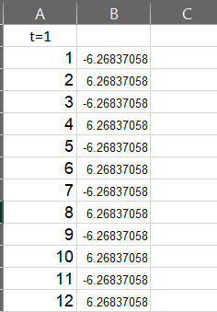

1. (a) Estimate the value of

by graphing the function in Excel. State your answer correct to two decimal places.

(b) Check your answer in part (a) by evaluating for values of *x* that approaches 0 in Excel.

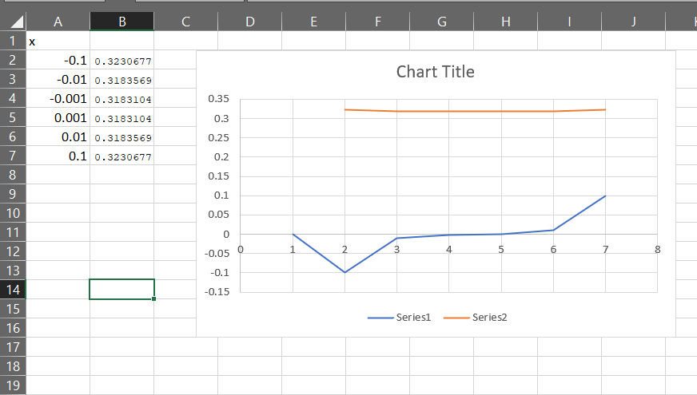

1. (a) Estimate the value of the limit to five decimal places. Does this number look familiar?

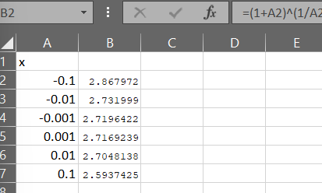

1. Illustrate part (a) by graphing the function in Excel

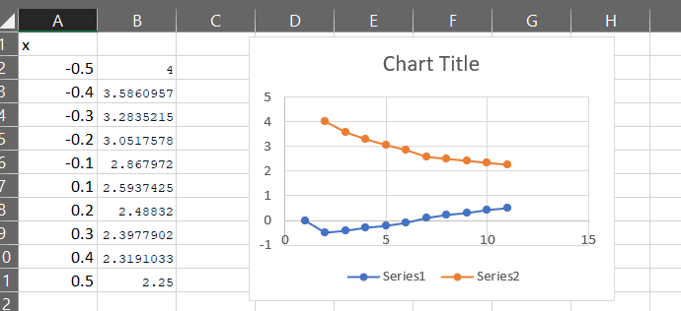

1. (a) Graph the function for in Excel. Do you think the graph is an accurate representation of *f*?

(b) How would you get a graph that represents *f* better?

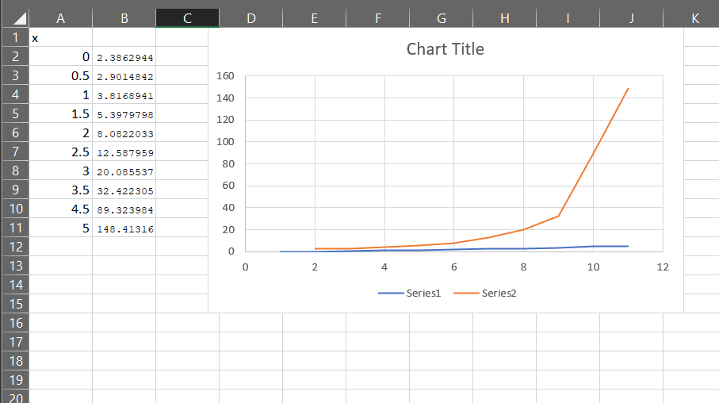

1. (a) Use numerical to find the value of the limit and verify it in Excel

(b) How close to *1* does *x* have to be to ensure that the function in part (a) is within a distance *0.5* of its limit?

